# 

## **American International University- Bangladesh (AIUB)**

## **Department of Computer Science & Engineering**

**Project Plan Title: Developing the Software Development Project Management Plan for Dhaka Subway Systems Automated Ticket Issuing System**

**Course Title: Software Development Project Management**

**Course Instructor: S.M. ABDUR BHUIYAN ROUF**

# **Index**

**1)****Title page** 1

**Index** 2

**2)Revision History Table** 2

**3) Introduction** 3

**4) Process model** 4

**5) Quality gate for each phase of software development** 5

**6) List of Tasks:** 7

**7) Estimation for each task:** 14

**8) Scheduling the tasks:** 16

**9) Prepare list of Milestones:** 18

**10.Stafing plan:** 19

**11) Monitoring and controlling mechanism** 21

**12) Risk Management** 22

**13) List of Deliverables** 22

**14) Defect tracking process** 23

**15) Metrics** 23

**16) Postmortem** 24

# **2)Revision History Table**

|  |  |  |
| --- | --- | --- |
| **Revised On** | **Version** | **Log** |
| **20-December-2020** | **1.01** | * The software will support interface to touch screen   monitors as well as keyboard interface.   * List of incoming trains, their destinations and arrival and departure times, fare, expected travel time * Limiting the number of tickets purchased at the same time. * Ticket cancellation before final confirmation of   the purchase. |
| **20-January-2021** | **1.02** | * Will support purchased ticket cancellation by the administrator. * Credit card transaction and validation. * Transaction using bill taka /coin * Next and previous navigation during ticket * Purchase process. |
| **20-February-2021** | **2.0** | * Ticket availability information. * Information display via web. * Account management * Oracle database server. * Responsible for the license * Fees of Oracle database server. |

# **3) Introduction**

This project is basically develop a software for automated ticket issuing system for Dhaka Subway Systems. In this part, an automated ticket issuing system sells subway tickets where user can easily select their destination, input their credit card and Pin. The subway ticket is issued and their credit card account charged with its cost. After that a user presses the start button, a menu display of potential destinations is activated along with a message to the user to select a destination. When the destination has been selected, users inserted credit card and check the validity. When card is validated the ticket is issued.

# **4) Process model**

**a. choose a model ---- agile**

**b. Justify why you chose this model**

1. Is a very realistic approach to software development.

2. Promotes teamwork and cross training.

3. Functionality can be developed rapidly and demonstrated.

4. Resource requirements are minimum.

5. Suitable for fixed or changing requirements.

6. Delivers early partial working solutions.

7. Good model for environments that change steadily.

8. Minimal rules, documentation easily employed.

9. Enables concurrent development and delivery within an overall planned context.

10. Little or no planning required.

11. Easy to manage.

12. Gives flexibility to developers.

**c. Software life cycle flowchart** 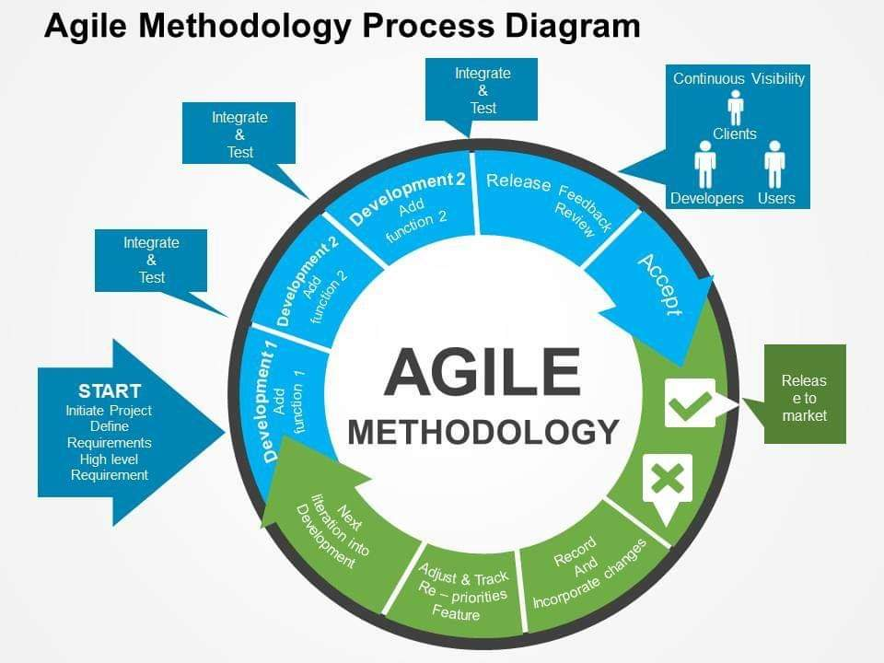

# **5) Quality gate for each phase of software development**

★ Quality gates are predefined milestones where a project is audited to see if it meets the necessary criteria to move into the next phase. Quality gates — which are also called “QGs” — are an important component of formal project management procedures used by larger organizations

The purpose of quality gates is to ensure every project follows a set of defined rules and best practices to avert common project risks and increase the odds of success. To be more blunt: With the help of quality gates, organizations can ensure that their project managers are doing their homework and not skipping any critical steps.

In their practical implementation, quality gates are organized as meetings that are scheduled at the end of every project phase.

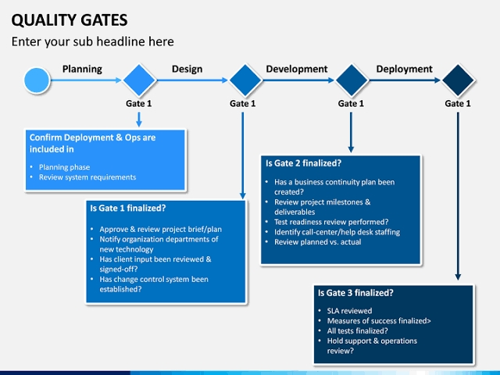

Quality gates are scheduled at the end of each project phase.

# **6) List of Tasks:**

**(START)**

Project Initiation-

|  |  |  |  |
| --- | --- | --- | --- |
| Task No. | Task Description | Responsible Member(s) | Task Status |
| 0.1.1 | Initiate project | Project manager | Complete |
| 0.1.2 | Define requirements | Project manager | Complete |
| 0.1.3 | High level requirements | Project manager & Subject matter expert | Complete |

**(Development-1)**

System Design-

|  |  |  |  |
| --- | --- | --- | --- |
| Task No. | Task Description | Responsible Member(s) | Task Status |
| 1.1.1 | Menu interface design | Architect | Complete |
| 1.1.2 | Database structure creation | Architect | Complete |
| 1.1.3 | Ticket availability information & fare display | Architect | Complete |
| 1.1.4 | Train arrival and departure time display | Architect | Complete |
| 1.1.5 | Source and destination selection display | Architect | Complete |
| 1.1.6 | Coin/Taka recognition and acceptance display | Architect | Complete |
| 1.1.7 | Ticket cancellation before final confirmation of the purchase display | Architect | Complete |
| 1.1.8 | Account management display | Architect | Complete |

System Build-

|  |  |  |  |
| --- | --- | --- | --- |
| Task No. | Task Description | Responsible Member(s) | Task Status |
| 1.2.1 | Menu interface build | Developer squad-1 | Complete |
| 1.2.2 | Database structure creation | Developer squad-2 | Complete |
| 1.2.3 | Ticket availability information & fare display | Developer squad-1 | Complete |
| 1.2.4 | Train arrival and departure time display | Developer squad-1 | Complete |
| 1.2.5 | Source and destination selection display | Developer squad-1 | Complete |
| 1.2.6 | Coin/Taka recognition and acceptance display | Developer squad-2 | Complete |
| 1.2.7 | ticket cancellation before final confirmation of the purchase display | Developer squad-2 | Complete |
| 1.2.8 | Account management display | Developer squad-2 | Complete |

Integrating & Testing-

|  |  |  |  |
| --- | --- | --- | --- |
| Task No. | Task Description | Responsible Member(s) | Task Status |
| 1.3.1 | Unit Testing | Test team & quality assurance team | Complete |
| 1.3.2 | Integration Testing | Test team & quality assurance team | Complete |
| 1.3.3 | System Testing | Test team & quality assurance team | In progress |
| 1.3.4 | Functional Testing | Subject matter expert & Project manager | In progress |

**(Development-2)**

System Design-

|  |  |  |  |
| --- | --- | --- | --- |
| Task No. | Task Description | Responsible Member(s) | Task Status |
| 2.1.1 | Touch screen menu selection and keyboard design display | Architect | Complete |
| 2.1.2 | Cancellation of transactions any time during transaction display | Architect | Complete |
| 2.1.3 | Credit card transaction display | Architect | Complete |
| 2.1.4 | Incoming trains, destinations and expected travel times display | Architect | Complete |
| 2.1.5 | Purchased ticket cancellation by the administrator display | Architect | Complete |
| 2.1.6 | Multiple ticket purchase display | Architect | Complete |

System Build-

|  |  |  |  |
| --- | --- | --- | --- |
| Task No. | Task Description | Responsible Member(s) | Task Status |
| 2.2.1 | Touch screen menu selection and keyboard design display | Developer squad-1 | Complete |
| 2.2.2 | Cancellation of transactions any time during transaction display | Developer squad-2 | Complete |
| 2.2.3 | Credit card transaction display | Developer squad-1 | Complete |
| 2.2.4 | Incoming trains, destinations and expected travel times display | Developer squad-2 | Complete |
| 2.2.5 | Purchased ticket cancellation by the administrator display | Developer squad-2 | Complete |
| 2.2.6 | Multiple ticket purchase display | Developer squad-1 | Complete |

Integrating & Testing-

|  |  |  |  |
| --- | --- | --- | --- |
| Task No. | Task Description | Responsible Member(s) | Task Status |
| 2.3.1 | Unit Testing | Test team & quality assurance team | Complete |
| 2.3.2 | Integration Testing | Test team & quality assurance team | Complete |
| 2.3.3 | System Testing | Test team & quality assurance team | In progress |
| 2.3.4 | Functional Testing | Subject matter expert & Project manager | In progress |

**(Development-3)**

System Design-

|  |  |  |  |
| --- | --- | --- | --- |
| Task No. | Task Description | Responsible Member(s) | Task Status |
| 3.1.1 | Limiting the number of tickets purchased at the same time by administrator access display | Architect | Complete |
| 3.1.2 | Next and previous navigation during ticket purchase process display | Architect | Complete |
| 3.1.3 | Information display via web | Architect | Complete |

System Build-

|  |  |  |  |
| --- | --- | --- | --- |
| Task No. | Task Description | Responsible Member(s) | Task Status |
| 3.2.1 | Limiting the number of tickets purchased at the same time by administrator access display | Developer squad-1 | Complete |
| 3.2.2 | Next and previous navigation during ticket purchase process display | Developer squad-1 | Complete |
| 3.2.3 | Information display via web | Developer squad-2 | Complete |

Integrating & Testing-

|  |  |  |  |
| --- | --- | --- | --- |
| Task No. | Task Description | Responsible Member(s) | Task Status |
| 3.3.1 | Unit Testing | Test team & quality assurance team | Complete |
| 3.3.2 | Integration Testing | Test team & quality assurance team | Complete |
| 3.3.3 | System Testing | Test team & quality assurance team | In progress |
| 3.3.4 | Functional Testing | Subject matter expert & Project manager | In progress |

Review & Release-

|  |  |  |  |
| --- | --- | --- | --- |
| Task No. | Task Description | Responsible Member(s) | Task Status |
| 4.1.1 | Project Review | Subject matter expert & Project manager | In progress |
| 4.1.2 | Project Release | Project manager | In progress |

**(If the project is not accepted)**

|  |  |  |
| --- | --- | --- |
| Task No. | Task Description | Responsible Member(s) |
| 5.1.1 | Record and incorporate changes | Project manager |
| 5.1.2 | Adjust & track re-priorities features | Project manager |
| 5.1.3 | Next iteration into development | Architect, developer squad 1 & 2, Test team, quality assurance team |

# **7) Estimation for each task:**

We used the Constructive Cost Model 81(COCOMO81) to estimate for each task because it is one of the most widely used software estimation models and we chose the semi-detached projects because we have mixed experience levels of members in our team.

Here,

LOC = 47,000 (Approx.)

Therefore, KLOC = 47k

Constants: c=3.0, k= 1.12, t= 0.35

Effort= c*(KLOC) ^ k

= 3.0*47^1.12

= 224 Person- Month (Approx.)

Development Time= 2.50*(Effort) ^ t

= 2.50*(224) ^ 0.35

= 17 Months (Approx.)

Required number of people= Effort / Development time

= 224/17

= 14 Persons

Productivity = KLOC / Effort

=47 / 224

= 0.21 KLOC/Person- Month (Approx.)

|  |  |  |
| --- | --- | --- |
| Tasks of phase | Days | Hours |
| Requirements Elicitation | 50 | 1200 |
| Project Planning | 80 | 1920 |
| Requirements Analysis | 48 | 1152 |
| System Design | 90 | 2160 |
| Object Design | 90 | 2160 |
| Implementation & Unit Testing | 80 | 1920 |
| System Integration & Testing | 80 | 1920 |
|  | Total= 518 or more | Total=12,432 or more |

Here, Each Engineer works for 8 hours a day and 5 days a week. Total project duration is 518 Working days. (Except holidays)

# **8) Scheduling the tasks:**

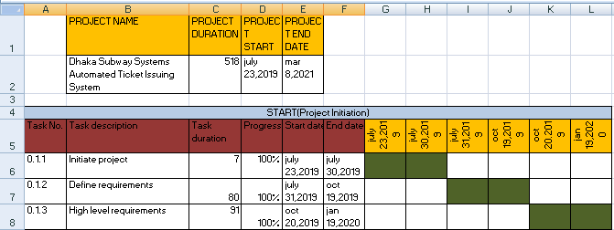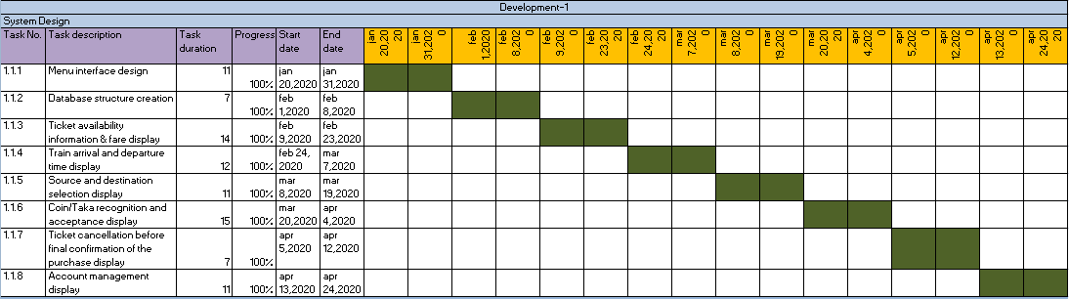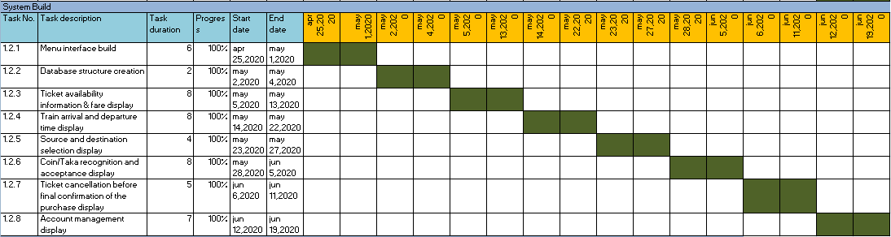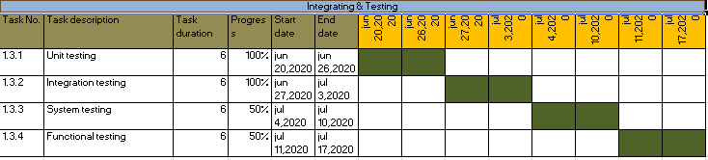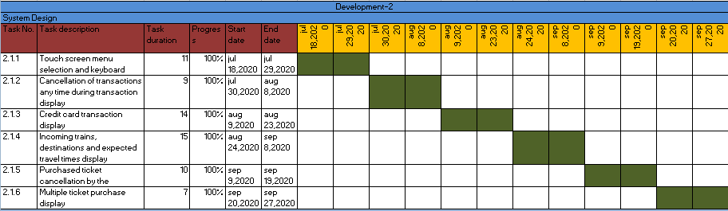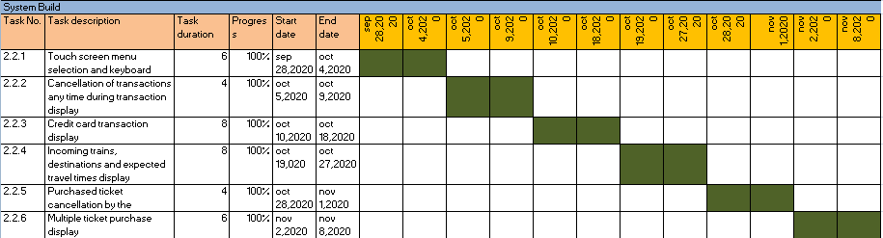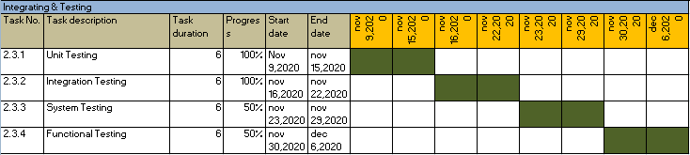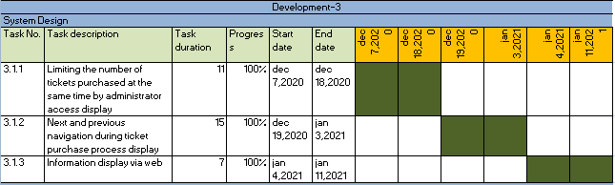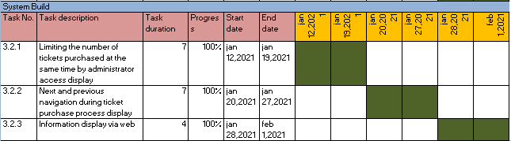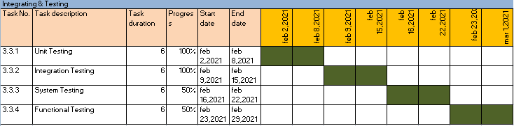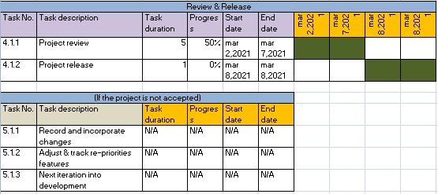

# **9) Prepare list of Milestones:**

|  |  |
| --- | --- |
| Date | Milestones |
| July 28 | Project Presentation by DNCC |
| August 15 | Planning & Analysis Review |
| September 10 | Project Design Review with DNCC |
| October 2 | Object Design Review |
| October 25 | Demo Software |
| November 16 | Internal Project Review |
| January 3 | Project Acceptance by DNCC |

# **10.Stafing plan:**

|  |  |  |  |  |  |
| --- | --- | --- | --- | --- | --- |
| Designation | Employee Names | Working hours | Number of project members | Project phase  (key phase) | Rate per hour |
| Project manager | Wasif Ashraf | 90 | 1 | All | $80 |
| Analyst  (lead) | Mushfika Jannat | 35 | 1 | Requirements | $65 |
| Business analyst | Mehedi Hasan | 20 | 1 | Requirements | $50 |
| Software architect | 1.Ullash Chowdhury  2.Shafiqul Islam | 22  27 | 2 | Design & Requirements | $100 |
| Programmer | 1.Iftekher Alam  2.Mosharaf Hossain | 20  20 | 2 | Programming,  Implementation | $150 |
| Software  Engineer  (head) | 1.Anik deb  2.Fahim Tayebee | 18  20 | 2 | Design & Allocation | $120 |
| Software  engineer | 1.Farhana Tasnim  2.Shufol Saha  3.Mahmud Hossain | 25  30  25 | 3 | Design & Allocation | $90 |
| Test engineer | 1.Shanto kumar Saha  2.Faria Zaman | 15  15 | 2 | Programming,  Design | $100 |
| Verification engineer | 1.Arman Hossain  2.Saim Kabir | 35  38 | 2 | Implementation,  Design,  Programming | $90 |
| Solution team | 1.Mohaiminul Islam  2.Ahamed Zubair  3.Ahsan Siam | 30  30  32 | 3 | Error solution | $110 |
| Quality analyst | Shanto Kumar Saha | 40 | 1 | Quality assurance,  Finalization | $180 |

# **11) Monitoring and controlling mechanism**

1. Weekly project meeting will take place at the lead project managers room.
2. A progress report of the last reporting period is written by the project manager.
3. The project manager and quality assurance manager read the minutes of the previous meeting.
4. These meeting are schedule once in a week. During these meeting, the project manager and quality assurance manager meet with the senior management. The following things need to be, done before a progress meeting.

A hard copy version of the progress report is delivered to the senior management.

# **12) Risk Management**

Some moment uncertain and unexpected condition occurs which includes a positive or negative affect on the project’s objective. Some possible risks discuss below.

**Safety, Environment and health risk:** This risk happened any time for our project estimation. Serious incidents can have a severe impact on schedule and costs.

**Communication Breakup risk:** Sometime communication collapse occur between two members or groupmates because of misunderstanding. Which hardly impact the project progress.

**Cost risk:** Cost risk impact the performance of the project improvement. Cost risk also lead to schedule risk if the schedule is extended because not enough funds are available to accomplish the project on time.

**Hardware incapacity and Defect at planning:** There is some chance to fall the company server during the development time or after finish the development of our software. Several times defect found for planning and modeling the project implementation.

**Political Crisis:** As it is a government funded project, any kinds of government change fall the development funding at risk.

# **13) List of Deliverables**

Basically software project management describing the technical citation for the development and delivery of the system.

* Requirement specification
* Setup of test system
* Setup of live system
* Data movement
* User interface
* Backend user preparing

# **14) Defect tracking process**

There can be taken some precautionary measurements to track defect.

1. In agile software development formal defect management processes help to build quality software.
2. The core purpose of defect management is to make the software more effective and efficient in order to increase its quality.
3. Requirements illustrated by the Dhaka subway systems stakeholders should be maintain and updated on a regular basis.
4. There should be satisfactory amount of interaction between the coder and the project manager to ensure the quality of system.
5. The project manager has to be communicative towards the stakeholders of Dhaka subway systems.
6. Breakdown the whole execution procedure into several parts and scrutinizes each part circumspectly to track down defects.
7. While coding phase starts, always check that the implementation is actually being based upon the requirements.

# **15) Metrics**

|  |  |  |
| --- | --- | --- |
| **Schedule** | Milestones | MS Project |
| **Cost and Effort Estimation** | Overall expenditures | MS Excel |
| **Defect Tracking** | Code defects | MS Excel |
| **Data Collection** | Requirements identified over time | MS Excel |
| **Requirement Defects** | Defects identified overtime | MS Excel |
| **Management** | Monitor and Control | MS Excel |
| **Quality Model and Measure** | Quality Gate of each phase | MS Excel |
| **Test progress** | Unit test integration test passed overtime | MS Excel |
| **Staff usage** | Total number of staffs worked, both in projected and actual | MS Excel |

# **16) Postmortem**

The overall project plan follows the Agile process. Agile retrospectives are done periodically during the lifetime of the project. This means that any problems or issues that arise during the project, can be also solved while executing. For this we can better prepared and respond better to changes during this time.

3 prototypes have to be delivered:

1. The basic first part contains core portion of the project with basic needs. Analysis is started before project planning is finished.
2. The next part contains many features which will give the users more advantages and usability will also increase the administration support of the system. System design is followed by object design.
3. The final increment will help to publish the web version of the project.

To run our project perfectly we always try to follow some rules in postmortem meeting. These are:

* Share an agenda before the meeting. Project name, project code, location, date, time should be include.

## Prepare by circulating a questionnaire. Some questions could include which is about : Agency-client communication, Project management, Information management, Issue management. Lots of many other things we can follow.

After every meeting we try to get some feedback from every team members. We hope that we will be able to complete this project successfully without any major interruption.